FOR IMMEDIATE RELEASE Contact: Julia Ross
Email: usoffice@harmonyforpeace.org
Phone: +1-484-995-0601

Harmony for Peace Foundation Presents its 2018 Jr. Peace & Music Ambassador Competition

Philadelphia, PA February 2nd, 2018- Harmony For Peace Foundation will be accepting audition applications for its 5th annual Junior Peace & Music Ambassador Competition. This program is open to young musicians of the Lower Age Category (ages 11-14) and Upper Age Category (ages 15-18). Music Categories include Piano, Strings, Brass/Winds, Voice and the Orchestral Accompaniment for Piano.

To encourage our mission of international understanding and collaboration, Harmony For Peace has created the unique role of “Junior Peace & Music Ambassador,” a honorary title given to a selected individual with an outstanding musical talent. The Foundation promotes peace and friendship across national and cultural borders through music. This competition is aimed to promote creativity for young musicians and to give recognition to those who exemplify the strong talent representative of the values of our organization. During a term, he or she will represent Harmony For Peace and give “community service” time to promote peace and friendship among young people through performances or cultural event activities, while celebrating cultural diversity. For the information on the jury panel, more details are available at https://www.harmonyforpeace.org/junior-peace-and-music-flyer.

Harmony For Peace will be accepting audition videos until February 15th. The final selection auditions will be held in March 2018 at Steinway Hall in New York (and for Philadelphia residents, final selection auditions will be held at Jacobs Music).

The selected winner will be presented with a feature performance slot at our concert in New York/Philadelphia, and other major cities where our Peace Concerts are held, and will receive an additional monetary prize of $300 at each age category. If applicable, there will be a runner up in each instrument category, whose information will be featured on our website and concert programs. Finalists may also be invited to perform at our concerts.

Its NEW Aurax Award for Orchestra Concerto Accompaniment Category for Piano will present a winning prize of $500. Aurax is an application that connects to your mobile device and uses a combination of innovative MIDI technology and high quality virtual orchestra concerto libraries. Musicians can use the application to practice with an orchestral accompaniment. Contestants are encouraged to apply to this new category.
For more information on competition details and the application process, please visit our site page here. XXX

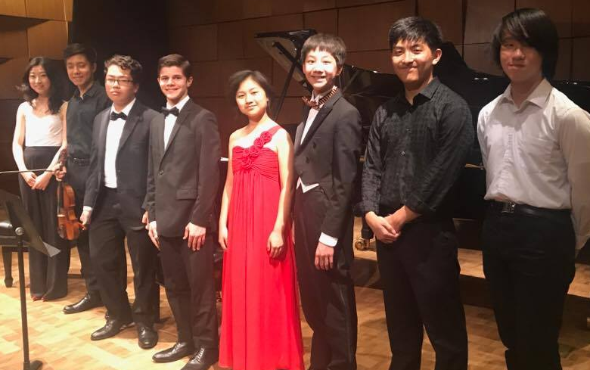
About Harmony for Peace: The Harmony for Peace Foundation, www.harmonyforpeace.org, seeks to promote cross-cultural understanding through the universal language of music, serving as a bridge among nations to promote mutual respect and a common path to world peace. Through performances, art exhibitions, events and advocacy we stand for a united voice of reason against violence, conflicts and nuclear proliferation across the globe.The Founder Tomoko Torii has spent the last 25 years creating opportunities for cross-cultural and international exchange. Known for a myriad of accomplishments in both business and musical and visual arts, Torii began Harmony For Peace Foundation in 2009 as a platform for artists worldwide for creating a global family through music and arts for more peaceful and harmonious world. Harmony For Peace is a NGO-501(C) 3 incorporated in the Commonwealth of Pennsylvania, USA.

